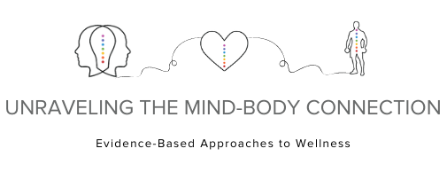

REQUEST FOR PROPOSALS

WORKSHOP FORMAT
To be considered for a workshop, presentation must:
- Align with one or several conference goals;
- Be interactive;
- Allow time for group discussion;
- Fit within a 90 minute time frame; and
- Be conducted with no more than two presenters.
PLEASE NOTE: Breakout session attendance can be anywhere from 10-75 people per session.

SAMPLE PRESENTATION TITLES
(Samples only, not indicative of final agenda.)
- Spirituality and Mental Health: What Clinicians Need to Know
- Mind Body Practices for Managing a Patient's Fear and Worry in Illness
- How to Teach Meditation and Deepen Your Own Practice
- Acceptance and Commitment Therapy and Compassion-Focused Therapy: Two New Potential Adaptive Strategies to Manage Stress
- Narrative Healing: How to Guide Your Patients' Use of Storytelling to Promote Health
- Mind Body Approaches to Addiction Recovery
- Positive Psychology Interventions
- Mindfulness and Behavior Change
- Tools for Integrating Mind Body Medicine into an Office Visit
- Music as Medicine
- Bringing Mind Body Medicine into your Daily Practice
- Food and Your Mood: Gut Health
- How Yoga and Meditation Positively Impact the Brain and Body

SUBMISSION INSTRUCTIONS AND GUIDELINES
Please submit the following Session Proposal Form to education@mhankyswoh.org. Multiple applications are allowed. Please also consider sharing any links to past presentations and/or lectures that would allow reviewers to see your presentation style. Submission Deadline: October 31, 2020.

BREAKOUT SESSION PROPOSAL
Presenter Name, Credentials: ____________________________________________________________
Title, Employer: _______________________________________________________________________
Email: ___________________________________ Phone: ________________________________
Title of Session: _______________________________________________________________________
Teaching Method(s): (PowerPoint, handouts, activity, discussion, Q & A, etc.)
____________________________________________________________________________________

Brief Description of the Session:
____________________________________________________________________________________
____________________________________________________________________________________
____________________________________________________________________________________
____________________________________________________________________________________
____________________________________________________________________________________
____________________________________________________________________________________
3-5 Learning Objectives:
- ____________________________________________________________________________________________________________________________________________________________________
- ____________________________________________________________________________________________________________________________________________________________________
- ____________________________________________________________________________________________________________________________________________________________________
- ____________________________________________________________________________________________________________________________________________________________________
- ____________________________________________________________________________________________________________________________________________________________________

